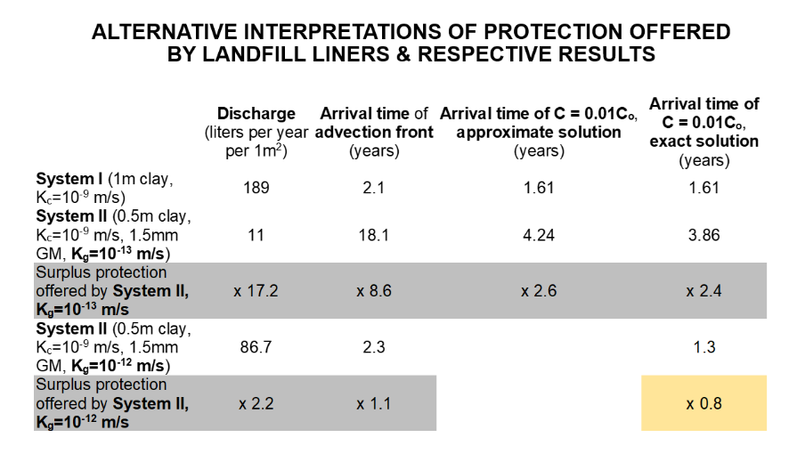
Interpretations of protection offered by landfill liners

• The aim of this exercise is to compare the protection offered (against spreading of leachate contaminants in the natural soil below the landfill) by (I) a 1-meter thick clay layer (d_{c} = 1m) (i.e. the reference “geological barrier” in EU landfill directive 1999/31/EC) and (II) a composite liner (a “geological barrier completed artificially” in 1999/31/EC) consisting of a compacted clay of thickness d_{c} = 0.5m (the minimum barrier thickness specified by 1999/31/EC) and a geomembrane of thickness d_{g} = 1.5mm (the minimum geomembrane thickness specified by Greek Ministerial Decision 114218/1997 for municipal waste landfills), as shown in Figure 1. The results are summarized in the slide above and in Table 1 (page 5) that follows the detailed calculations: different interpretations correspond to different surpluses of protection.
• For the comparison, we will assume failure of the leachate removal system, which resulted in 5 meters of leachate accumulating on top of the low-permeability liner.
• We will interpret the vague “protection” of the landfill directive 1999/31/EC by three alternative measures:
(1) specific discharge of leachate passing through the liner,
(2) contaminant travel time (advection only) from upstream point 1 to downstream point 2 (see Figure 1) and
(3) time for breakthrough of concentration C = 0.01C_{o}, where C_{o} is contaminant concentration in the leachate.
Parameters & conditions assumed:
• Clay Hydraulic conductivity K_{c} = 10⁻⁹ m/s, Porosity n_{c} = 0.4
• Geomembrane Apparent hydraulic conductivity K_{g} = 10⁻¹³ m/s, Porosity n_{g} = 0.02
• Coefficient of hydrodynamic dispersion D = 32 cm² / year (1x10⁻¹⁰ m²/s)
• Assumptions: steady state flow, sorption is ignored, drainage layer offers no resistance to flow, clay is saturated, geomembrane (GM) is intact (see comment on page 5).

Calculations: Specific discharge per 1m² of bottom liner (l/m²- year)
Contaminant travel time (advection only) from point 1 to 2 (year)
Time for breakthrough of concentration C = 0.01C_{o} (year)
Figure 1. The two liner systems compared using alternative criteria (1), (2), (3) to quantify protection offered for a scenario whereby 5 m of leachate (not to scale) has accumulated over the low-permeability bottom liner.

Calculation of hydraulic conductivity
K_{I} = K_{c} = 10⁻⁹ m/s
Calculation of equivalent hydraulic conductivity in the vertical direction for System II:

$$K_{II}=\frac{\sum{d_{i}}}{\sum{\frac{d_{i}}{K_{i}}}}=\frac{d_{c}+d_{g}}{\frac{d_{c}}{K_{c}}+\frac{d_{g}}{K_{g}}}=\frac{0.5m+0.0015m}{\frac{0.5m}{10^{-9}\frac{m}{s}}+\frac{0.0015m}{10^{-13}\frac{m}{s}}}=3.2×10^{-11}m/s$$
(1) Calculation of specific discharge, Q
We need to solve the problem of one-dimensional flow, which requires to calculate a hydraulic gradient across the bottom liner. Elevation heads z are computed considering as datum the downgradient face of the liner, as shown in Figure 1. We assume that the water pressure at downgradient point 2, which is in contact with natural soil, is atmospheric (P_{w2}= 0).

System I
Upstream face of bottom liner – point 1 in Figure 1
h₁ = P_{w1}/γ_{w} + z₁= 5m+1m = 6m
Downstream face of bottom liner – point 2 in Figure 1
h₂ = P_{w2}/γ_{w} + z₂= 0m + 0m = 0m

Calculation of hydraulic gradient and Darcy velocity
$$i_{I}=\frac{Δh_{I}}{ΔL_{I}}=\frac{h_{1}-h_{2}}{d_{c}}=\frac{6m}{1m}=6$$
$$v_{I}=K_{I}i_{I}=10^{-9}\frac{m}{s}×6=6×10^{-9}\frac{m}{s}$$

System II
Calculation of hydraulic gradient and Darcy velocity
$$i_{II}=\frac{Δh_{II}}{ΔL_{II}}=\frac{h_{1}-h_{2}}{d_{c}+d_{g}}=\frac{5.5m}{0.5m}=11$$

$$v_{II}=K_{II}i_{II}=3.2×10^{-11}\frac{m}{s}×11=3.5×10^{-10}\frac{m}{s}$$
Calculation of specific discharge, Systems I and II
$$Q_{I}=K_{I}i_{I}A=10^{-9}\frac{m}{s}×6×1m^{2}=6×10^{-9}\frac{m^{3}}{s}$$

→ Q_{Ι} = 189 l/year

$$Q_{II}=K_{II}i_{II}A=3.2×10^{-11}\frac{m}{s}×11×1m^{2}=3.5×10^{-10}\frac{m^{3}}{s}$$

→ Q_{ΙI} = 11 l/year

(2) Calculation of contaminant travel time (advection only)
We need to calculate average linear velocity (advection velocity or seepage velocity)

System Ι

${\overline{v}}_{c}=\frac{v_{I}}{n_{c}}=\frac{6×10^{-9}\frac{m}{s}}{0.4}=1.5×10^{-8}\frac{m}{s}$
Contaminant travel time due to advection only is calculated as the ratio of (i) the distance between the contaminant source (upstream face of low-permeability layer) and the point of interest (downstream face of low-permeability layer) and (ii) the average linear velocity:

$$T_{I}=\frac{d_{c}}{{\overline{v}}_{c}}=\frac{1m}{1.5×{10}^{-8}\frac{m}{s}}=772days$$
→ Τ_{Ι} = 2.1 years

System ΙΙ
$$T_{II}=\frac{d_{g}}{{\overline{v}}_{g}}+\frac{d_{c}}{{\overline{v}}_{c}}=\frac{d_{g}}{{v_{II}}/{n_{g}}}+\frac{d_{c}}{{v_{II}}/{n_{c}}}=\frac{0.0015m}{3.5×10^{-10}\frac{m}{s}/0.02}+\frac{0.5m}{3.5×10^{-10}\frac{m}{s}/0.4}$$

→ Τ_{ΙΙ}= (1 + 6614) days → Τ_{ΙΙ} = 18.1 years

(3a) Calculation of breakthrough time for contaminant concentration equal to 0.01 of the contaminant concentration in the leachate (arrival time of C = 0.01Co) – approximate solution
We use the first term of the solution of the one-dimensional advection-dispersion equation and check the value of the Peclet number to assess how accurate is the one-term approximation (Fetter, 1999). The solution is for a semi-infinite domain, whereas we have a barrier of finite thickness, but for the purposes of a comparison it is adequate. The parameters we need are the calculated average linear velocity $\overline{v}$and the given coefficient of hydrodynamic dispersion D.

System Ι
${\bar{v}}_{c}$= 1.5x10⁻⁶ cm/s = 47.3 cm/ year

$\frac{{\overline{v}}_{c}x}{D}=\frac{47.3×100}{32}=148$ > 100 → we expect that the first term of the solution will give a good approximation (Fetter, 1999)
if → erfc α = 0.02 → α = 1.645
$1.645=\frac{100-47.3t}{2\sqrt{32t}}$
for $\sqrt{t}=T→1.645=\frac{100-47.3T^{2}}{11.31T}$→ T = 1.27 → t_{Ι} = 1.61 years
System ΙΙ

We will take into account transport through the clay layer only:
${\overline{v}}_{c}=\frac{3.5×10^{-8}\frac{cm}{s}}{0.4}$ = 2.76 cm/ year
$\frac{{\overline{v}}_{c}x}{D}=\frac{2.76×50}{32}=4.31$ << 100 → working with only the first term of the solution is expected to produce a sizeable inaccuracy
$$1.645=\frac{50-2.76t}{2\sqrt{32t}}$$
For → $1.645=\frac{50-2.76T^{2}}{11.31T}$ → Τ=2.06 → t_{II} = 4.24 years

(3b) Calculation of breakthrough time for contaminant concentration equal to 0.01 of the contaminant concentration in the leachate (arrival time of C = 0.01Co) – exact solution

We use both terms of the solution to the one-dimensional advection-dispersion equation with the help of the educational software by Valocchi et al. (2014).

System I
For seepage velocity 47.3 cm/ year, hydrodynamic dispersion D = 32 cm² / year, concentration C = 0.01C_{o} arrives at x = 100cm in t_{I} = 1.61 years (see Appendix).

System II
Seepage velocity 2.76 cm/ year, hydrodynamic dispersion D = 32 cm² / year, concentration C = 0.01C_{o} arrives at x = 50cm in t_{II} =3.86 years.

Comments:
• As expected, calculating travel time based on advection only leads to non-conservative solutions for materials of low hydraulic conductivity materials.
• The three interpretations of “protection”, as (1) specific discharge per m², (2) travel time considering advection only and (3) breakthrough time needed for contaminant concentration equal to 0.01 of the contaminant concentration in the leachate (arrival time of C = 0.01Co), provide different equivalency factors as shown in Table 1.
• When the calculations are repeated for an order-of-magnitude higher apparent hydraulic conductivity for the geomembrane (K_{g}=10⁻¹² m/s), the composite liner offers adequate protection according to the first two criteria, and inadequate protection according to the third (arrival time of C = 0.01C_{o}).
• The simplifications considered are deemed to be adequate for the purposes of comparison. For a more realistic assessment of the impact of a landfill, it is recommended to also take into account flow and transport through the geomembrane defects; alternative methods are compared by Kandris and Pantazidou (2012).

Table 1. Comparison of protection offered by clay-geomembrane (GM) composite liner (System II) with respect to the reference liner (System I) using three alternative measures to quantify protection.

 | Alternative interpretations of protection offered by landfill liners
 | Discharge  (liters per year per 1m²) | Arrival time of advection front  (years) | Arrival time of C = 0.01C_{o}, approximate solution  (years) | Arrival time of C = 0.01C_{o}, exact solution  (years)
System I (1m clay, K_{c}=10⁻⁹ m/s) | 189 | 2.1 | 1.61 | 1.61
System II (0.5m clay, K_{c}=10⁻⁹ m/s, 1.5mm GM, K_{g}=10⁻¹³ m/s) | 11 | 18.1 | 4.24 | 3.86
Surplus protection offered by System II, K_{g}=10⁻¹³ m/s | x 17.2 | x 8.6 | x 2.6 | x 2.4
System II (0.5m clay, K_{c}=10⁻⁹ m/s, 1.5mm GM, K_{g}=10⁻¹² m/s) | 86.7 | 2.3 |  | 1.3
Surplus protection offered by System II, K_{g}=10⁻¹² m/s | x 2.2 | x 1.1 |  | x 0.8

Acknowledgements

The exercise draws inspiration and most input parameters from an assignment of the course Soil Behavior 273 taught by Professor Jim Mitchell at UC Berkeley in the year 1988-1989.

References

1999/31/EC Council Directive of 26 April 1999 on the landfill of waste, Official Journal of the European Communities 16.7.1999 L182.
Fetter, C.W. (1999). Contaminant Hydrogeology, 2nd edition, MacMillan.
Kandris, K. and Pantazidou, M. (2012). Landfill base liners: Assessment of material equivalency and impact to groundwater, Geotechnical and Geological Engineering, 30:1:27-44 (doi: 10.1007/s10706-011-9447-4).
Valocchi, A.J., Werth, C.J., Decker, J.J., Hammond, G., Zhou, P. and Hafiz, M. (2014). Interactive Models for Groundwater Flow and Solute Transport, Computer Applications in Engineering Education, https://doi.org/10.1002/cae.20000

Appendix

Applet output for seepage velocity 47.3 cm/ year, hydrodynamic dispersion D = 32 cm² / year, and fixed time 1.61 years: at x = 100cm the concentration is C/ C_{o} = 0.01

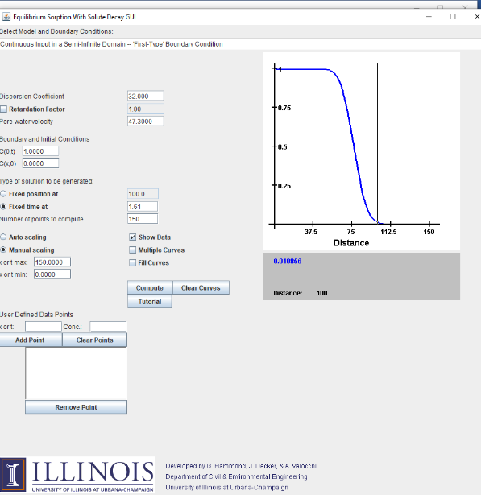

Interactive applets are found here:
http://hydrolab.illinois.edu/gw_applets/ (accessed May 10, 2023).

