Bridget Lokoe
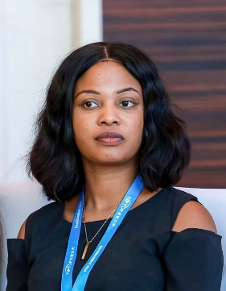
Bridget Nana Ama Lokoe is a civil engineer currently working as a geotechnical/Tailings Engineer with WSP in the mining industry. She is currently based in Ghana after a secondment program in Indonesia. She has an MBA in Entrepreneurship and Leadership from Jain University and an MSC. In Engineering Construction Management from The University of East London. Bridget has extensive experience in projects within the roads, infrastructure, and mining sectors. She also is involved in partaking in third party TSF audits and Engineering management. Bridget defines success as the ability to balance family, social, and personal life.
Bridget Joined the YMPG in the year 2022 and has actively been involved in promoting Geotechnical Engineering in young professionals. She currently holds the position of Chairperson for the period between 2026 to 2030.
Max Gabriel Barbosa

Max Gabriel Barbosa holds a Master's and a PhD in Civil and Geotechnical Engineering from the University of Brasília (UnB), with an exchange year at Heriot-Watt University. His research and professional work focus on soil improvement, grouting, retaining structures, tunnels, and design-build approaches in geotechnical engineering. Currently, he serves as the Technical Director at SCO Engenharia Geotécnica, where he leads geotechnical projects and construction initiatives. Max also serves as an ad-hoc director of ABMS (Brazilian Society for Soil Mechanics and Geotechnical Engineering) and is an associate member of DFI (Deep Foundations Institute), DBIA (Design-Build Institute of America), and ITA-AITES (International Tunnelling and Underground Space Association).
As a Brazilian, Max is passionate about soccer and is a die-hard Palmeiras fan. He also enjoys spending his free time with his family, reading business and detective novels, and hiking.

Tong Zhu
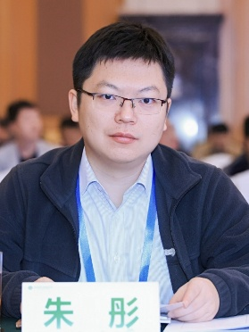
Tong Zhu is a senior engineer at China State Construction Engineering Co., Ltd. (CSCEC). He obtained his doctoral degree from the School of Civil Engineering at Tsinghua University, subsequently conducting postdoctoral research at CSCEC for two years. He serves as the vice secretary-general of the Young Engineer Work Committee of the Chinese Institution of Soil Mechanics and Geotechnical Engineering. His research primarily focuses on earthquake engineering of urban underground structures, and he has conducted innovative research in the field of structure-soil dynamic interaction in liquefiable ground. His research findings have been incorporated into the China Standard for Seismic Design of Underground Structures and applied to the seismic design of several major engineering projects. As a member of Young Member Presidential Group (YMPG) of the ISSMGE, he aims to contribute to this group to facilitate exchanges between international geotechnical organizations and young scholars and engineers.
In his free time, Tong enjoys engaging in various outdoor activities, such as running, cycling, and traveling.
Rara Dwi Noviarti
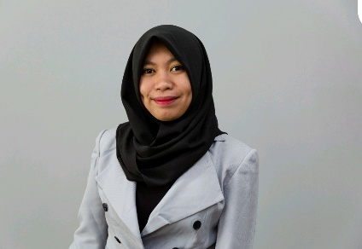
Rara is a geotechnical engineer with 9 years of professional experience across Singapore and Indonesia. She holds both a bachelor’s and a master’s degree in civil engineering from Gunadarma University. Throughout her career, Rara has worked on a diverse range of geotechnical projects, including high-rise buildings, major transportation projects, data centres, land reclamation, and water infrastructure projects. She is currently based in Singapore, working with Arup, where she contributes to the design and delivery of complex engineering projects within the built environment.
Beyond her technical work, Rara is passionate about inspiring the next generation of engineers and encouraging young people to discover the impact, challenges, and opportunities within geotechnical engineering. Outside of engineering, Rara enjoys spending time in nature, particularly hiking and exploring beautiful landscapes.
Jiapei Du
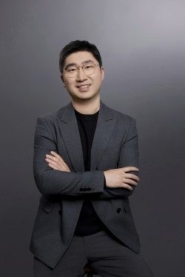
Dr. Jiapei Du obtained his PhD degree in Geotechnical Engineering from RMIT in June 2023. From July 2023 to June 2025, he has served as a postdoctoral research fellow at RMIT University. In July 2025, he was appointed to a continuing Lecturer position in Civil and Infrastructure Engineering at RMIT University. His major research interests include nanoscale characterization and modelling of expansive soil behaviour, and the development of nano-engineered cementing materials for complex geological environments.
Dr. Du has received several prestigious awards, such as the ARC Discovery Early Career Research Award 2025, ISSMGE Bright Spark Lecture Award, 2023 Science and Technology Award from the China Association of Oceanic Engineering, 2023 Engineering Prize from RMIT University, the 2022 Featured People in ARC Smart Pavements Hub, the 2021 Chinese Government Award for Outstanding Self-financed Student Abroad, and the 2020 Cover Page Article in The Journal of Physical Chemistry C. He has served as an Associate Editor for Environmental Geotechnics, an Editorial Board Member of Scientific Report, a Guest Editor for Frontiers in Materials (Q2) and Frontiers in Chemistry (Q1), and as a reviewer for 60+ peer-reviewed journals. Dr. Du also served as the secretary for the 8th Asia-Pacific Conference on Unsaturated Soils.

