Bare Essentials of Soil Mechanics by John Burland
A suite of five short videos (2′ to 6′) on the engineering behavior of soils. The emphasis is on the particulate nature of soils and its implications for soil strength.
https://expeditionworkshed.org/sub_categories/soil/
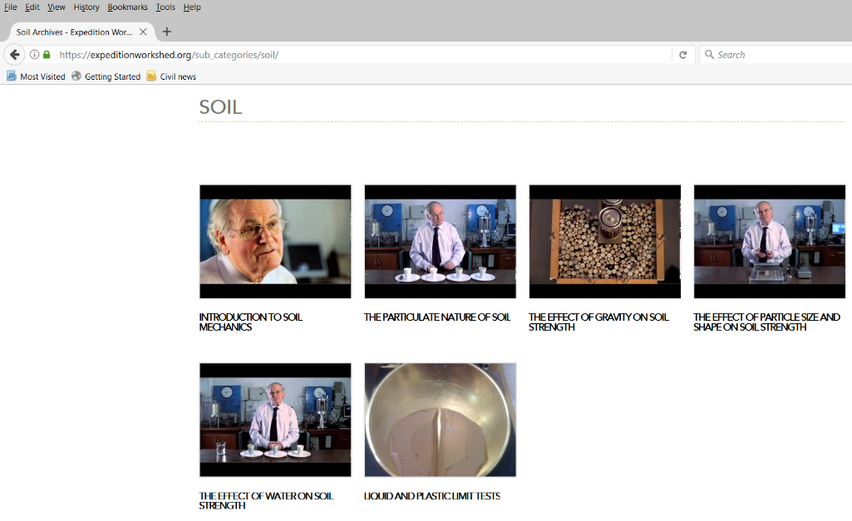
• 1. Introduction to Soil Mechanics (2′ 41′′)
https://www.youtube.com/watch?v=ZuofAC9rq58
• 2. The particulate nature of soils (2′ 20′′) – Main point: soil strength = shearing resistance at particle contacts
https://www.youtube.com/watch?v=mB3O6hQAoZA
• 3. The effect of weight/gravity on soil strength (4′ 48′′)
https://www.youtube.com/watch?v=-EUQcluC-ZQ
• 4. The effect of particle size distribution and shape on soil strength (3′ 26′′)
https://www.youtube.com/watch?v=qY_PRCmg85E
• 5. The effect of water on soil strength (6′ 08′′) – Main point: built up of water pressure reduces contact force (and, hence, shearing resistance). The same video continues with the effect of surface tension on soil strength.
https://www.youtube.com/watch?v=a-6YbkZJ5UY
Example use of the Burland videos (in the first course on Soil Mechanics taught at NTUA). When we first talked about soil composition and structure, I asked students to watch videos No 2 and 3. Then, when we talked about stresses due to soil’s self-weight and effective stress, I reminded students about the effect of particle size distribution and shape on soil strength (attached slide No 1: memorable visuals from video No 3) and brought once more to their attention the Burland videos by incorporating in the presentation a still picture-memorable visual from video No 5. Again I asked students to watch video No 5 in their own time.
Marina Pantazidou, 30-4-2018

